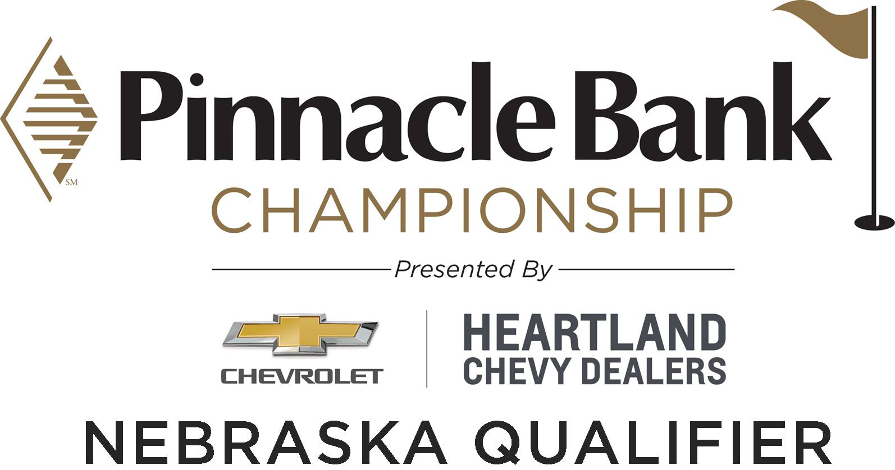
PROCEDURES &
INFORMATION SHEET

Qualifying:

Date: Tuesday, June 12, 2018

- Course: ArborLinks

Address: 6038 H Road, Nebraska City, NE 68410 Phone Number: (402) 873-4334

PLEASE NOTE:

THIS QUALIFIER IS EXCLUSIVELY FOR THOSE WITH “NEBRASKA TIES.” IN ORDER TO BE ELIGIBLE, YOU MUST MEET AT LEAST ONE (1) OF THE FOLLOWING CRITERIA. IF YOU DO NOT, YOUR ENTRY WILL BE REJECTED.

Eligibility (Pros and Amateurs):

- Any current legal resident of the State of Nebraska.
- Any Nebraska Section PGA Members and PGA Associates in good standing.
- Anyone currently attending a college or university in Nebraska.
- Any graduate of a college or university in Nebraska.
- Anyone born in Nebraska and graduated from a high school (MUST provide High School transcripts) in Nebraska.
NOTE: Amateurs must carry a GHIN handicap and when applied to the qualifying course slope will generate a handicap of four (4) or less. The Nebraska Golf Association and Nebraska Section PGA reserves the right to verify the handicap index of amateurs and to refuse anyone not meeting the requirements.
Entry Fee:

$175.00

Entry fee must accompany online application and MUST be payable via credit card. Entry fee includes: green fee, cart fee and range usage on the competition day.

Entry Deadline:
Deadline for receipt at the PGA Section office of entries by eligible players shall be as follows:
- Friday, June 8, 2018 – 5:00 pm CST

All players must enter by the applicable deadline. Entries late or incomplete are not acceptable. Telephone and faxed entries will NOT be accepted. The PGA Section office is not responsible for rejected credit cards.

Field Size:
Maximum field size will be 60 players.

Qualifying Spots and Alternates:

The winner of this qualifier will receive an exemption into the Web.com Tour Pinnacle Bank Championship which will be played July 16-22 at The Club at Indian Creek in Elkhorn, Nebraska.

Note: There will be a sudden-death playoff immediately following play to determine the winner of the final qualifier as well as the 1st and 2nd alternates.

Format:
36 Hole Stroke Play

Withdrawals:
Applicants must withdraw prior to the entry deadline to be eligible for an entry fee refund. Other refunds will be considered only in the case of injury or other disability which requires medical attention or serious personal emergency. A player, who withdrawals for medical reasons defined above, will be required to send supporting documents to the Nebraska Section PGA offices and must be received within 36 hours to be considered for a refund. Regardless, all entry fee refunds are subject to a $25 administrative fee.

Contestants who withdraw during the round may be subject to disciplinary action.

Starting Times:
Starting times will be available no later than 6:00 p.m. two-days preceding the qualifying competition at www.nebraskapga.com. Starting times and groupings are made at the discretion of the Nebraska Section PGA and Nebraska Golf Association and specific requests will not be granted.

Practice Rounds:
Practice rounds must be arranged with ArborLinks.

Rules of Golf:
Play shall be governed in accordance with the Rules of Golf of the United States Golf Association, as modified by the Nebraska Section PGA Local Rules and Conditions of Competition card and supplemented by the Notice to Competitors. Questions or disputes (including equipment rulings) shall be settled by the on-site Rules Committee appointed by the Nebraska Section PGA and Nebraska Golf Association, whose decision shall be final.

Transportation:
Players and caddies may walk or ride in a cart – subject to the following provisions:

- A maximum of 2 carts will be allowed per group
- Players will have priority seating over caddies
- A maximum of two people may ride in a cart at any given time
- Players are not required to have a caddie
- Players/caddies may carry their clubs or use a manual/motorized pull cart (must supply their own)

Groove Specifications:
The player's clubs must conform to the groove and punch mark specifications in the Rules of Golf that are effective from January 1, 2010.

An online resource page on grooves, at www.usga.org/grooves, offers more details on the Condition of Competition, Frequently Asked Questions, and a link to the Informational Club Database, where players can see whether the clubs they play with conform to the groove regulations can be found below.

http://www.usga.org/rules-hub/grooves/informational-club-database.html
Penalty for making a stroke with club in Breach of Condition - Disqualification.

Appearance:
ALL PLAYERS must wear long pants at all times on competition days.

While on the host facility property, players shall present a neat appearance in both clothing and personal grooming. Blue jeans, shorts, cutoffs, T-shirts or shirts with no collar shall not be worn.

Caddies: While on the host facility property, caddies may wear either long pants or tailored solid colored knee length shorts. Blue jeans, cutoffs, T-shirts or shirts with no collar shall not be worn. Smooth rubber sole shoes are required. Sandals, open toe shoes, and golf shoes with traditional metal or soft spikes are prohibited.

Conduct:
While on host facility property during qualifying rounds; players and caddies shall conduct themselves in a professional manner. The Nebraska Section PGA and Nebraska Golf Association reserves the right to remove a player from the qualifying competition for; non competitiveness; conduct unbecoming a professional by the player; conduct unbecoming a professional by the players’ caddie.

**The consumption of ALCOHOL is prohibited at all times during any qualifying round(s) and includes any suspension of play.

Reduction or Cancellation:
If in the judgment of the on-site Rules Officials or designee, whose decision shall be final, conditions render commencement or continuation of tournament play inadvisable, play shall be postponed until such time as the Rules Official or designee determines that such weather conditions or other occurrences or conditions have improved sufficiently for play to commence or resume.

In situations involving adverse weather conditions or any other occurrence or condition, our priority is the completion of the qualifying competition. Every effort will be made to achieve this objective by the end of the scheduled competition day. If this is not possible, dependent on such factors as weather, course conditions and course availability, play may be extended beyond the original competition date. Under no circumstances will the competition extend beyond one additional day.

The Nebraska Section PGA and Nebraska Golf Association reserves the right to change the format, venue(s), qualifying spots and other criteria as presently contemplated. In such cases, the decision of the on-site Nebraska Section PGA and Nebraska Golf Association Official in charge shall be final.

------------------------------------------------------------------------------------------------------------------------------------------------------------

By submission of this entry, I agree to the following:

I hereby consent and grant permission to (i) Nebraska Section PGA, Nebraska Golf Association, Riverside Golf Club, Wilderness Ridge Golf Club, ArborLinks, Pinnacle Bank, Web.com TOUR, together with their sponsors, and (ii) to all media (collectively the “Consented-to Parties”), to use all information submitted in my application/registration, and any photograph, videotape, motion pictures, recording and any other record of these qualifying events including results, my likeness, and name for any lawful purpose related to the qualifying event and post-qualifying event publicity including, without limitation, the Pinnacle Bank Championship. I hereby grant, release, and discharge certain rights arising from my appearance, in any picture, video, advertisement, or other recording or presentation as a result of my participation in the qualifying events. I hereby grant and release to the Consented-to Parties the right to use my name, likeness, and personal information, and to photograph, videotape, make motion pictures, recordings or any other record of; to reproduce, duplicate, publish, exhibit, use or transmit the same or any parts thereof, by any means, in any manner and for any purpose whatsoever; and to do the same perpetually. This voluntary grant and release will not be made the basis of a future claim of any kind against the Consented-to Parties. I release and discharge the Consented-to Parties from any cause of action arising from my participation.

I acknowledge that I have voluntarily agreed to participate in the qualifying events. I agree that there are certain risks inherent in the participating in golf. I hereby assume all risks of damages, injury, including death, incurred or suffered by me while at the qualifying events.

I hereby release, remise and forever discharge on behalf of myself and my heirs, personal representatives, successors, the Nebraska Section PGA, Nebraska Golf Association, Riverside Golf Club, Wilderness Ridge Golf Club, ArborLinks, Pinnacle Bank, Web.com TOUR, together with all of their respective officers, directors, employees, agents, members, affiliates, and subsidiaries (collectively referred to as the “Indemnified Persons”) of and from any cause of action, claim, demand, right, damage, loss, expense and/or compensation of any nature whatsoever including, but not limited to, any claim of negligence, which I or my heirs, personal representatives, successors, and assigns may now have, or in the future shall have against the Indemnified Persons on account of personal injury, property damage, death or accident of any kind, the consequences thereof and the consequential damages therefrom, arising out of or in any way related to my participation in the qualifying events. I agree to indemnify and hold harmless the Indemnified Persons from and against any and all loss, damage or expense caused by my negligent or intentional and wrongful conduct, or actions.

Nebraska Section PGA is not responsible for incorrect or inaccurate entry information, whether caused by internet users or by any of the equipment or programming associated with or utilized in the registration or application process or by any technical or human error which may occur in the process of any entry application or registration. Nebraska Section PGA is not responsible for computer system, phone line, hardware, software or program malfunctions, or other errors, failures or delays in computer transmissions or network connections that are human or technical in nature.

